New Gradebook Quick Guide

What is in this document?

This document provides a quick guide on setting up grading policies for your course.

Applying grading policies in new Canvas gradebook

By default, courses in the new gradebook have an automatic posting policy which means assignment grades are visible to students as soon as grades are entered in the gradebook or submitted in SpeedGrader.

Apply Manual Grade Posting Policy for course

To ensure assignment grades are hidden from students until posted the Manual post policy should be applied in the course. This replaces the “muted” function in previous gradebook.

- Select Grades from Course navigation menu
- In gradebook click on the Settings cog on top right

- Click Grade Posting Policy and select Manually Post Grades option then click Update
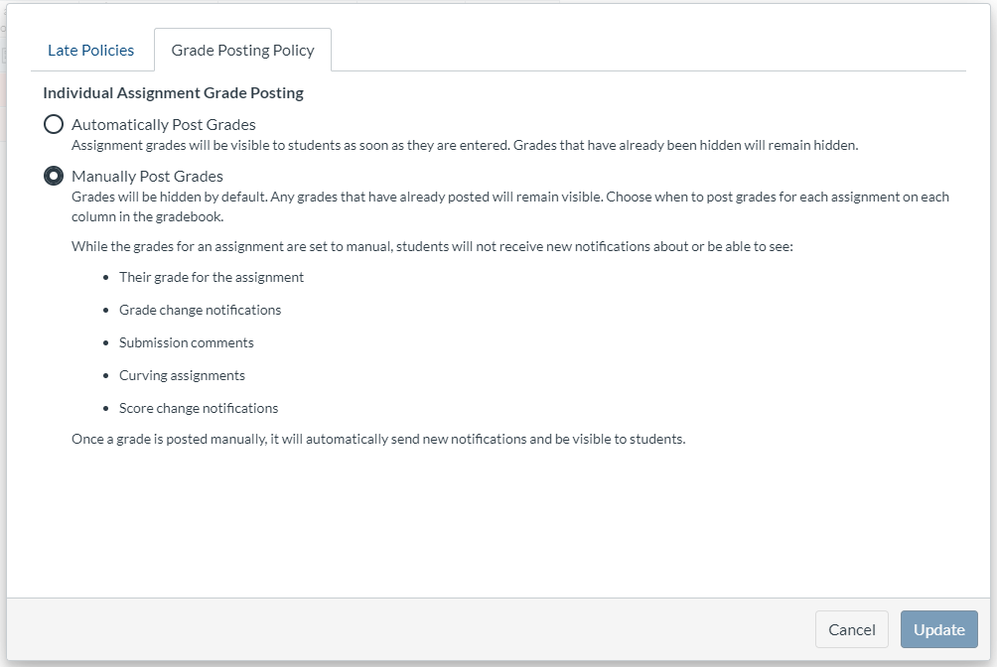

Treat Missing Assignments as 0 for course

To ensure assignment grades are calculated correctly for missed assignments apply a grade policy for missing submissions. There is no longer an option to “treat ungraded as zero”.

- In Gradebook click on the Settings cog on top right

- Select automatically apply grade for missing submissions as 0% then click Update

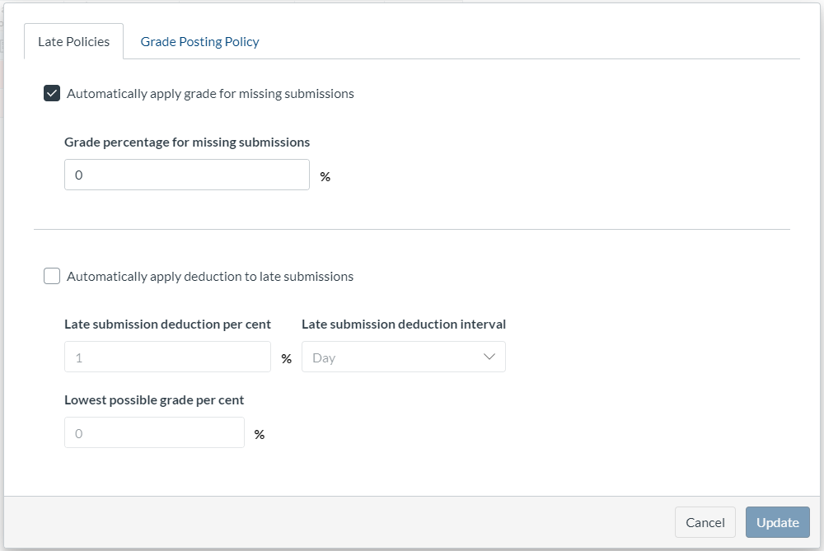

Instructure Guide: How do I apply a Missing Submission policy in the New Gradebook?

https://community.canvaslms.com/docs/DOC-16568-4152826328

Automatic Feedback for Quiz results

To ensure students receive immediate feedback for Quiz results apply an automatic policy for individual quiz assignments.

Grades are automatically released for quiz attempts after policy has been applied.
Any quiz attempts completed before policy applied will need to be posted manually.

- Select the assignment menu for the quiz and select Grade Posting Policy

- Select post grades Automatically and click Save

